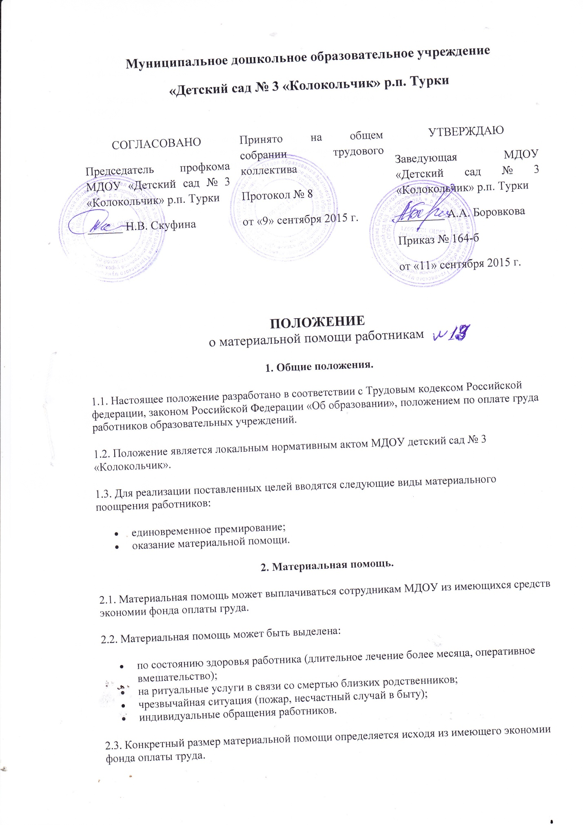

|  |  |  |  |  |
| --- | --- | --- | --- | --- |
| **C:\Users\Public\Documents\2018_01_17\IMG_0006.jpg**   |  |  |  | | --- | --- | --- | |  |  |  | |  |
|  |  |